**Assignment 6 - ML-Classification-Navie Bayes**

|  |  |
| --- | --- |
| **Not Purchased** | **Purchased** |
| 0 | 257 |
| 1 | 143 |

|  |  |  |  |
| --- | --- | --- | --- |
| **Actual Class** | | | |
| **Predicted Class** |  | **True (Not Purchased)** | **Purchased** |
| **True (Not Purchased)** | 72 | 7 |
| **Purchased** | 13 | 28 |

**Evaluation Metrics - Accuracy**

**Accuracy for Purchased and Not Purchased Data set:**

What is the percentage of correct classification of both (“Not Purchased” and “Purchased”) to the total input in the test set?

**True (Not Purchased) + True (Purchased)**

**True (Not Purchased) + True (Purchased) + False (Not Purchased) + False (Purchased)**

**Evaluation Metrics - Recall**

**Recall for Not Purchased:**

What is the percentage of correct classification of “Not Purchased” to the total input of (Not Purchased) in the test set?

**True (Not Purchased)**

**True (Not Purchased) + False (Not Purchased)**

**Recall for Purchased:**

What is the percentage correct classification of “Purchased” to the total input of (Purchased) in the test set?

**True (Purchased)**

**True (Purchased) + False (Purchased)**

**Evaluation Metrics - Precision**

**Precision for Not Purchased:**

What is the percentage of correct classification of “Not Purchased” to the Sum of correctly classified as “Not Purchased” and wrongly classified as “Not Purchased in the test set?

**True (Not Purchased)**

**True (Not Purchased) + False (Purchased)**

**Precision for Purchased:**

What is the percentage of correct classification of “**Purchased**” to the Sum of correctly classified as “Not Purchased” and wrongly classified as “Purchased in the test set?

**True (Purchased)**

**True (Purchased) + False (Not Purchased)**

**Evaluation Metrics - F1-Measure**

**F1-Measure for Not Purchased:**

What is the overall performance of “Not Purchased”?

2 * **Recall (Not Purchased) * Precision (Not Purchased)**

**Recall (Not Purchased) + Precision (Not Purchased)**

**F1-Measure for Purchased:**

What is the overall performance of “Not Purchased”?

2 * **Recall (Purchased) * Precision (Purchased)**

**Recall (Purchased) + Precision (Purchased)**

**Macro Average:**

**Precision:**

What is the average performance of Precision (Correctly and wrongly classified)?

**Precision of “Not Purchased” + Precisionof “Purchased**

**2**

**Recall:**

What is the average performance of Recall (Correctly and wrongly classified)?

**Recall of “Not Purchased” + Recall of “Purchased**

**2**

**F1-Measure:**

What is the average performance of F1-Measure (Correctly and wrongly classified)?

**F1(Not Purchased) + F1(Purchased)**

**2**

**Weighted Average**

**Precision:**

What is the sum of product of proportion rate (Weight) of each class

**Precision (“Not Purchased”) * 79/120 + Precision (“Purchased”) * 41/120**

**Recall**

What is the sum of product of proportion rate (Weight) of each class

**Recall (“Not Purchased”) * 79/120 + Recall (“Purchased”) * 41/120**

**F1-Measure**

What is the sum of product of proportion rate (Weight) of each class

**F1 (“Not Purchased”) * 79/120 + f2 (“Purchased”) * 41/120**

**BernoulliNB**

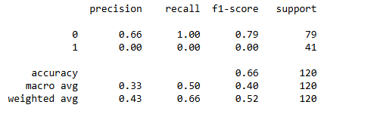

**MultinomialNB**

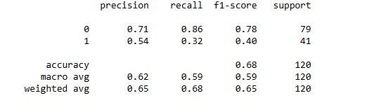

**CategoricalNB**

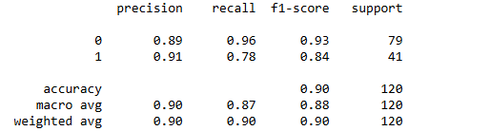

**ComplementNB**

